VPC Connect privet Network

Note:- 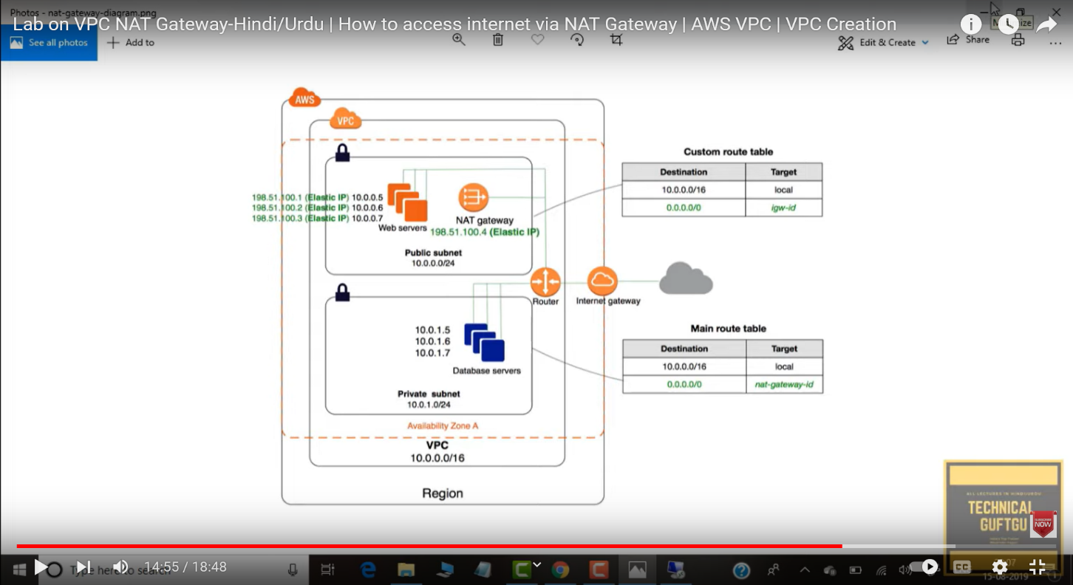

Go to **vpc**

Select **your Vpcs**

**Create vpc**

**Put name:- new-vpc**

**IP CIDR:- 10.0.0.0/16**

**Create VPC**

**Select Subnet**

* **Create subnet first**

**Select:-new-vpc**

**Put:-public-subnet**

**Availablity zone:- any -- if you want to select then you select also**

**IPV4:-10.0.1.0/24 select any one -- you set own ip also**

* **Create subnet second**

Select **Create subnet**

**Select:-new-vpc**

**Put:-privet-subnet**

**Availablity zone:- any -- if you want to select then you select also**

**IPV4:- 10.0.1.0/24 select any one -- you set own ip also**

**Create subnet**

Select **internet getway**

**Crate internet getway**

**Name:-new-IT**

**Create internet getway**

**Go to action – attach vpc- select vpc- new-vpc**

Select **NAT gatways**

**Create NAT gatway**

Put name:-**New-NAT**

Select **subnet**:-select **public** --- q ki vo internet public se lenga then iske ip se access krenge

Select **allocate elastic ip**  -- if you have already elastic ip then you select also

**Create nat gatway**

Go to the **route table**

* **Create route table**  first

Name:-**public-RT**

Vpc:-**new-vpc**

**Create route table**

* **Create route table**  second

Name :- **privet-RT**

Vpc:- **new-vpc**

**Create route table**

Select **public-RT** --- now you see the routes and subnet associations

* **Select routes:-edit routes:- add route**

**0.0.0.0/0 select internet gatway (select) save changes**

Select **subnet associations**

Edit **subnet associations:-public**  public ko public k sath select krna

**Save associations**

Select **privet-RT**

* **Select routes:-edit routes:- add route**

**0.0.0.0/0 select NAT Gatway (select) save changes**

Select **subnet associations**

**Edit subnet associations**:-**Private**  Private ko Private k sath select krna

Go to **EC2**

* **Launch Instance first**

Name:- **public instance**

**Ami**

**T2 micro**

Key pair:- **newkey** (select)

Network setting :- **edit**

Select vpc :- **newvpc** (select)

Subnet :- select **(public subnet)**

Select :-**Enable**

Select **Create security group**

Put name :- **public-SG**

**Inbound port ssh ,http, & https all three put**

**Launch instance**

* **Launch Instance second**

Name:- **private instance**

**Ami**

**T2 micro**

Key pair:- **newkey** (select)

Network setting :- **edit**

Select vpc :- **newvpc** (select)

Subnet :- select (**private subnet**)

Select :-**Disable ----bcoz vo instance ko public ip show nhi hogi only private**

Select **Create security group**

Put name :- **public-SG**

**Inbound port ssh ,http, & https all three put**

Launch instance

Go to the **gitbash**

**Cd Download**

**Chmod 600 newkey.pem**

**Scp -i newkey.pem newkey.pem ec2-user@ip(public ip):/home/ec2-user**

| |

**192.168.13.135** **path of ec2-user**

**Done**

Go to the **ec2-user**

**Ssh -i newey.pem ec2-user@(public IP)**

Now you see the **e2-user@(public IP) console**

**ls**  - now you see the **key**

**Chmod 600 newkey.pem**

**Ssh -i newkey.pem ec2-user@(privet IP)**

Now you see the login to the **privet ec2-user console**